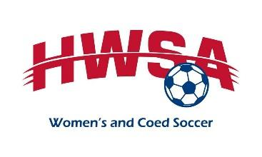
2023 Scholarship Application
Houston Women’s Soccer Association
PO Box 541531
Houston, TX 77254
scholarship@hwsa.org
Deadline: March 31, 2023 11:59 PM CST
Recipients will be notified:April 30, 2023, then checks will go out by mail
Award announcement at the HWSA Meeting: August 2, 2023, 7:30 PM
For your application to be considered, you must submit the following to scholarship@hwsa.org by March 31, 2023 at 11:59 PM CST, the subject of all emails must be your Last Name, First Initial, and High School (ex: Adams S CNHS).
- Application form typed or printed legibly in black or blue ink and signed.
- An essay of no more than 500 words describing your favorite soccer memory OR the impact of soccer in your life.
- A statement of no more than 250 words describing how you and your family will pay for college and how this scholarship will benefit you.
- One letter of recommendation from someone who can speak to your commitment to education and soccer.
Personal and Academic Information
Full Name: Date of Birth: / /
Last First Middle Month Day Year
Home Address:
Number Street City State Zip Code
Phone #: Email:
Parent/Guardian: Parent/Guardian:
High School: Did you participate on your high school team?
Soccer Club(s)/Team(s):
Programs, Colleges, Universities applied to: Possible Major: Accepted? Attending?

I certify that all the information contained in this application is true and factual.
Applicant’s Signature | Printed Name | Date
Parent or Guardian Signature | Printed Name | Date
* Scholarships will be awarded based upon the above factors, weighing the soccer essay and financial need statement.

