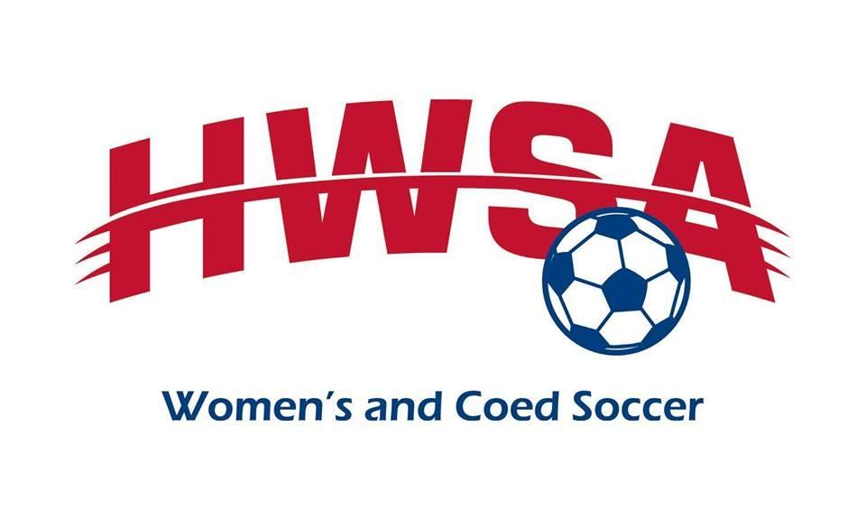
2022 Scholarship Information
Houston Women’s Soccer Association
PO Box 541531
Houston, TX 77254
scholarship@hwsa.org
Deadline to apply: April 30, 2022 11:59 PM Central (Houston) Time
Recipients will be notified: May 31, 2022, then checks will go out by mail
Awards will be announced at the HWSA Fall Meeting on August 3, 2022, at 7:30 PM.

Dear Coaches, Administrators, Parents, and Students,
Please invite all greater Houston area high school and HWSA soccer players who are heading to college or currently attending college to apply for one of two $500 College Scholarships awarded by the Houston Women’s Soccer Association (HWSA) in 2022.
The Houston Women’s Soccer Association exists to support amateur soccer for women of all ages and skill levels regardless of race, religion, sexual orientation, disability, color or creed. Please check out our women’s and coed leagues for an opportunity to continue playing soccer in the future.
The two scholarships available this year are:
The $500 HWSA Patty Hayes Memorial Scholarship, need-based, supporting our greater Houston soccer community.
The $500 HWSA Community Soccer Scholarship, supporting our greater Houston soccer community.
For your application to be considered, you must submit the following to scholarship@hwsa.org by April 30, 2022 at 11:59pm CST, the subject of all emails must be your Last Name, First Initial, and High School (ex: Adams S CNHS).
- The application form typed or printed legibly in black or blue ink and signed.
- An essay of no more than 500 words describing your favorite soccer memory OR the impact of soccer in your life.
- A statement of no more than 250 words describing how you and your family will pay for college and how this scholarship will benefit you.
- One letter of recommendation from someone who can speak to your commitment to education and soccer.
* Scholarships will be awarded based upon the above factors, weighing the soccer essay and financial need statement.

Thank you,
HWSA Scholarship Committee

